Praise for the Scott Dailey Trio

“WOW, my favorite kind of music!”
- Audience member, San Mateo, California

“Your concert was the highlight of my week. Your group sounded great!”
- Audience member, Benicia, California

“…another night of big laughs and powerful music!”
- Promotional message, Angelicas Bistro, Redwood City, California

“I have been listening to your group’s CD, “Fast and Loose,” with vocals by Bernie Soubirou. I love it…”
- Fan comment posted on www.scottdaileymusic.com

“You are a great group…”
- Maria Rutenburg, owner, Chez Nous Café, Redwood City, California

“Looking forward to another fabulous performance!”
- Audience member, Yosemite West, California

“Dailey’s trio interprets an array of celebrated standards with polish, precision and a little whimsy.”
- George Fendel, Jazz Society of Oregon, reviewing the trio’s album, “Fast and Loose”

“One of my favorite musicians and a great music educator…one of the best.”
- Dr. Pascal Bokar Thiam, Department of Music, University of San Francisco; former owner, Savanna Jazz Club in San Francisco and San Carlos, California; founder and CEO, Silicon Valley Jazz Festival

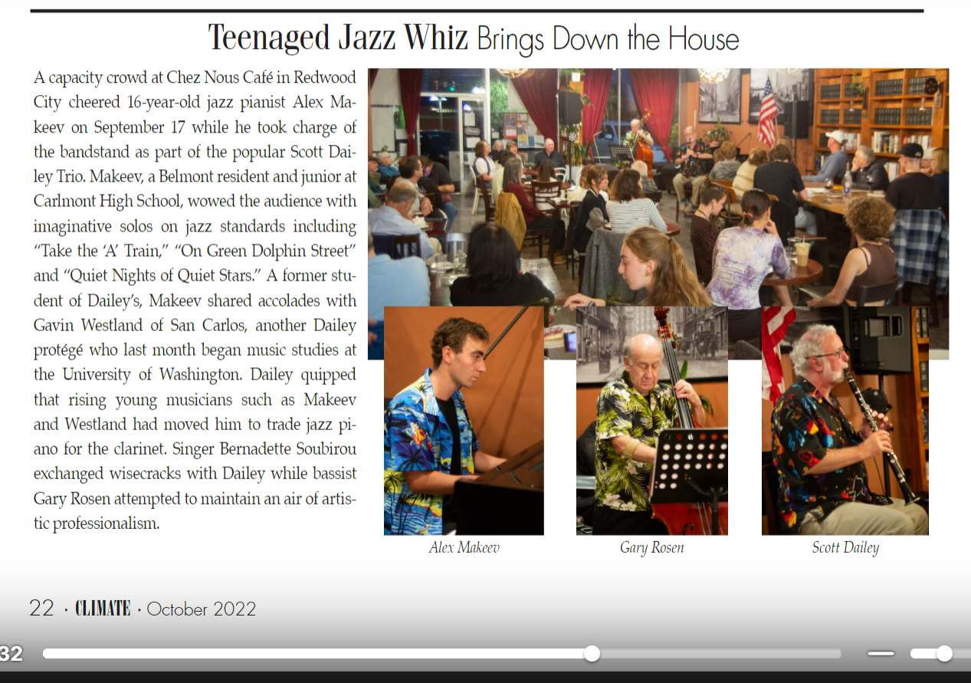
Climate Magazine, San Francisco Peninsula, October 2022

