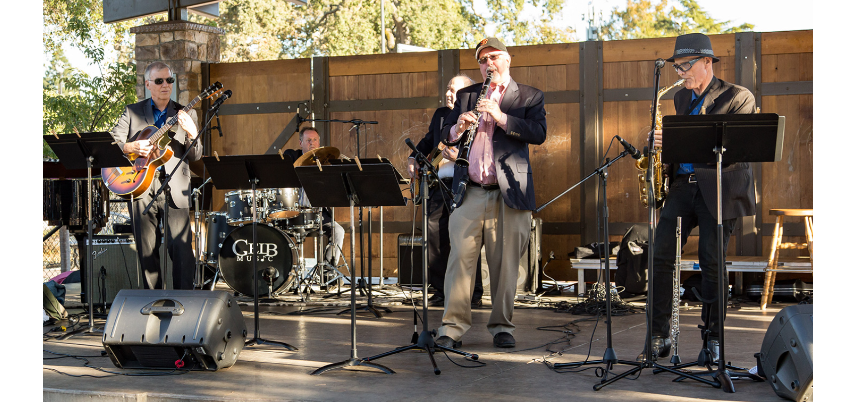
Silicon Valley Jazz Festival, Northern California
Front, L-R: Bob Navarra, Scott Dailey, Wiley Rankin

Scott Dailey Trio and Friends
“Dailey’s trio interprets an array of celebrated standards with polish, precision and a little whimsy…. In addition to Dailey’s cleanly honed, sprightly touch on the piano, I was impressed with [Bob] Navarra’s subtle artistry on guitar.”
- George Fendel, Jazz Society of Oregon
Performing since the late 1990s and led by jazz pianist and clarinetist Scott Dailey, the trio specializes in the Great American Songbook and often expands to a sextet that includes guitar, sax, blues harp and vocals. With a wide audience originally in the San Francisco Bay Area and now in metropolitan Seattle, the group combines virtuosity with sharp humor from the always sardonic Scott Dailey and banter between him and vocalist Bernadette Soubirou. (There is a Saint Bernadette Soubirous, but this Bernadette is no saint. Imagine Ellen DeGeneres squaring off against George Carlin, with music.)
The group’s album, “Fast and Loose,” has received praise for its unusual takes on American standards. The ensemble regularly features guitarist Bob Navarra, who excels in everything from bebop to ballads, and bluesman Wiley Rankin, whose energetic alto sax and harmonica playing typically inspires rousing ovations. Bob and Wiley are also quick with stinging one-liners, which they toss out at their peril around Scott and Bernadette.
Contact:
Scott Dailey
31008 W. Lake Morton Dr. SE
Kent, WA 98042
650-714-9578
scott.w.dailey@gmail.com
www.scottdaileymusic.com

